# Problem 3 – Grocery List

Problem for exam preparation for the ["JS Front-End" course @ SoftUni](https://softuni.bg/trainings/3976/js-front-end-february-2023) .

Submit your solutions in the SoftUni judge system at <https://judge.softuni.org/Contests/3879/Exam-Preparation-II>.

**Working with Remote Data**

For the solution of some of the following tasks, you will need to use an up-to-date version of the **local REST service**, provided in the lesson’s resources archive. You can [read the documentation here](https://github.com/softuni-practice-server/softuni-practice-server).

**Environment Specifics**

Please be aware that every JS environment may **behave differently** when executing code. Certain things that work in the browser are not supported in **Node.js**, which is the environment used by **Judge**.

The following actions are **NOT** supported:

* **.forEach()** with **NodeList** (returned by **querySelector()** and **querySelectorAll()**)
* **.forEach()** with **HTMLCollection** (returned by **getElementsByClassName()** and **element.children**)
* Using the **spread-operator** (**...**) to convert a **NodeList** into an array
* **append()** in Judge (use only **appendChild()**)
* **prepend()**
* **replaceWith()**
* **replaceAll()**
* **closest()**
* **replaceChildren()**
* Always turn the collection into a **JS array** (forEach, forOf, et.)

If you want to perform these operations, you may use **Array.from()** to first convert the collection into an array.

## Requirements

Write a JS program that can load, create, remove and edit a list of products. You will be given an HTML template to which you must bind the needed functionality.

First you need to install all dependencies using the "**npm install**" command

Then you can start the front-end application with the "**npm start"** command

You also must also start the **server.js** file in the server folder using the "**node server.js**" command in another console **(BOTH THE CLIENT AND THE SERVER MUST RUN AT THE SAME TIME)**

At any point, you can open up another console and run "**npm test**" to test the **current state** of your application, it's preferable for **all of your test to pass locally** before you submit to the judge platform, like this:

Картина, която съдържа текст

Описанието е генерирано автоматично

## Endpoints

* [**http://localhost:3030/jsonstore/grocery/**](http://localhost:3030/jsonstore/grocery/)
* [**http://localhost:3030/jsonstore/grocery/**](http://localhost:3030/jsonstore/grocery/)**:id**

## Load Products

Clicking the **[Load Products]** button should send a **GET** request to the server to fetch all products in your local database.

Each task is a list item in the following format:

**<tr>**

**<td class="name">{Product}</td>**

**<td class="count-product">{count}</td>**

**<td class="product-price">{price}</td>**

**<td class="btn">**

**<button class="update">Update</button>**

**<button class="delete">Delete</button>**

**</td>**

**<tr>**

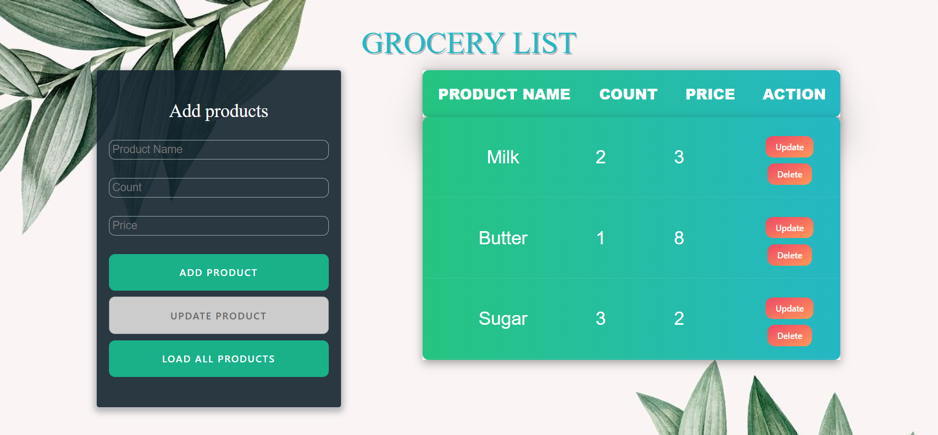

## Add Products

Clicking the **[Add Product]** button should send a **POST** request to server, creating a new product with the **name, count** and **price** from the input values and after the successful creation you should send another **GET** request to fetch all products, including the newly added one.

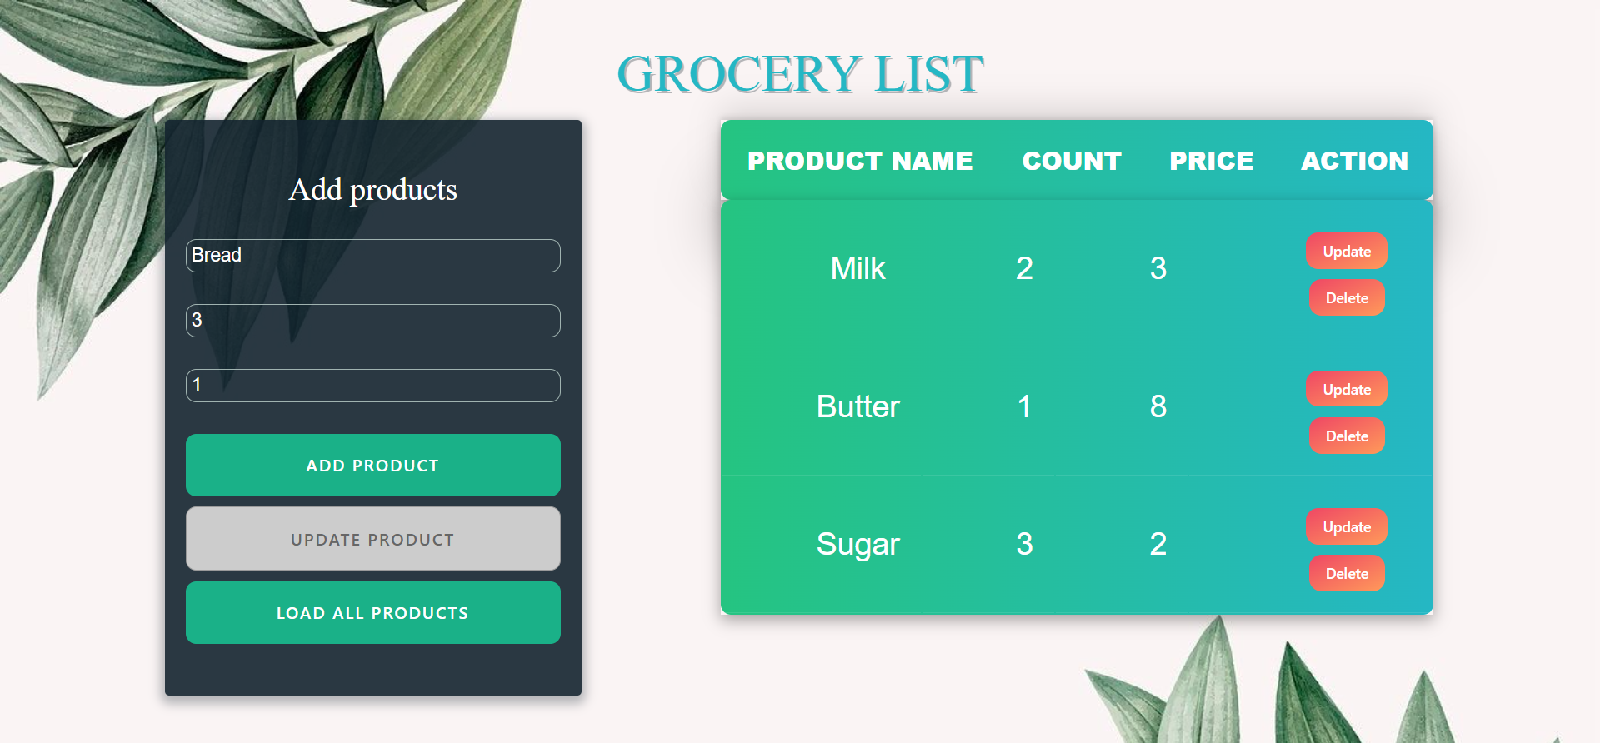

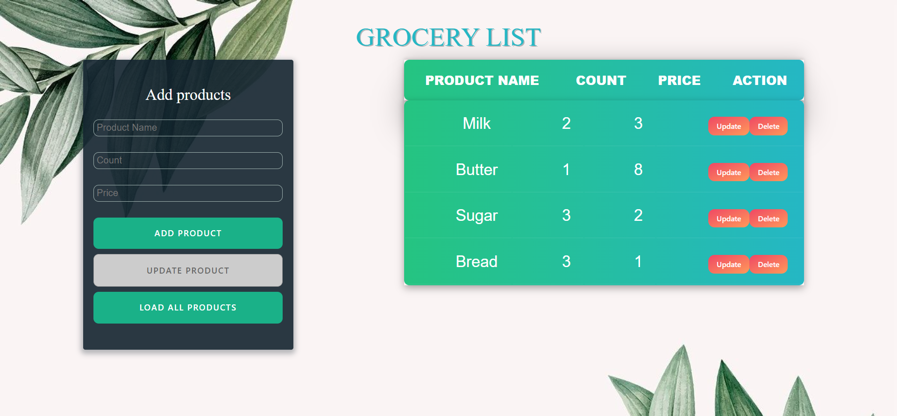

## Delete Products

Clicking the **[Delete]** button should send a **DELETE** request to the server and remove the item from your local database. After you’ve removed it successfully, **fetch** the items **again**.

## Update Products

Clicking the **[Update]** button should change the DOM Structure for that list element. **[Update** **Product]** button must be activate.

After clicking the [**Update Product]** button you should send a **PATCH** request to the server to **modify the name, count or price** of the changed item, after the successful request you should **fetch the items again** and see that changes have been made.

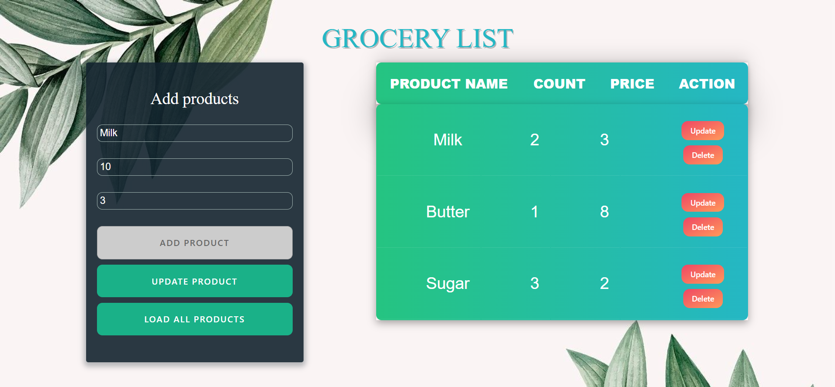

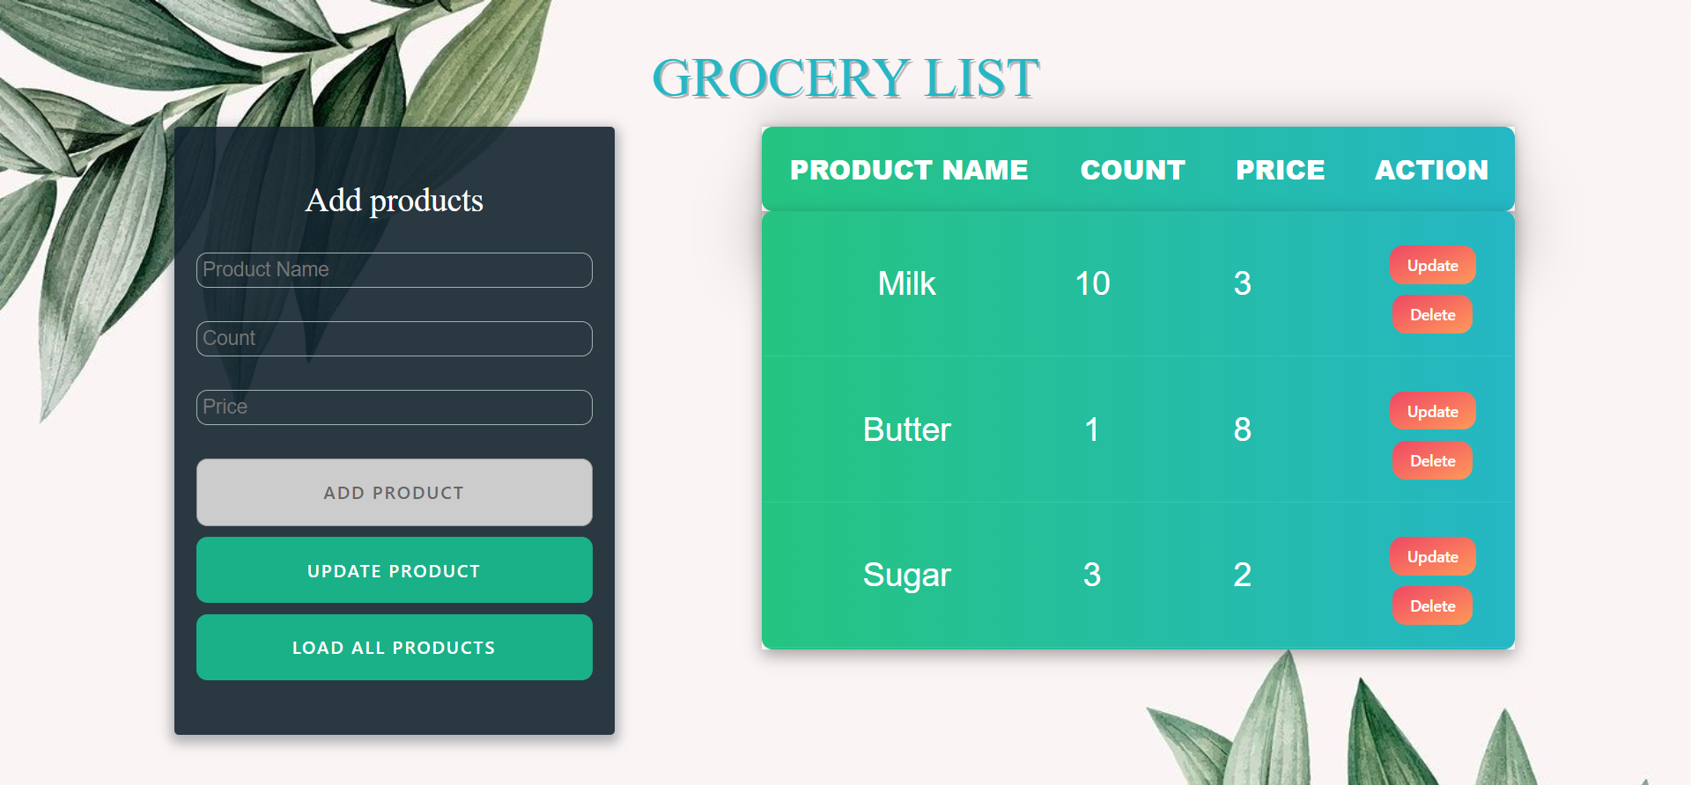

## Submitting Your Solution

Place in a **ZIP** file the content of the given resources including your solution. Exclude the node_modules & tests folders. Upload the archive to Judge.

Картина, която съдържа текст

Описанието е генерирано автоматично

Картина, която съдържа текст

Описанието е генерирано автоматично